TABLE OF CONTENTS

|  |  |  |
| --- | --- | --- |
| S.NO | CHAPTERS | PAGE NO |
| 1 | PROJECT DESCRIPTION | 2-3 |
| 2 | SOURCE CODE | 4-40 |
| 3 | OUTPUT WINDOW | 41-43 |

CHAPTER 1

PROJECT DESCRIPTION

This project is made using the features of HTML (Hyper Text Markup Language), CSS (Cascading Style Sheet) and JavaScript. This project is to develop an individual’s skills in full stack development. I have showcased my skills and proficiency in this language. This project is a website for a tourism and travel service organization, the Tropical Tourism. It consists of a login page, a sign-up page, a menu bar and a website detailing the service offered. All the attributes of the website are designed and built using the HTML and CSS features. The validation of this website is done using JavaScript features.

For the validation conditions of our website, it is programmed to:

* Accept username and password from the user.
* The password length must be of at least 8 characters
* The email should be a valid email

For the validation in the sign-up page, it is programmed to:

* Accept username and password from the user.
* The password length must be of at least 8 characters
* The email should be a valid email
* The password entered should be confirmed

The above contents are used to proceed further to the webpage, otherwise, an alert message is popped with a message login failed or it insists the user to recheck their form. I have implemented the concepts of using id, classes, internal and inline CSS styling features. I have also implemented the usage of basic structural HTML tags, form tags etc.

The stylings in this webpage, are achieved using CSS style sheets. The effects used in this website are widely ranged some of them are, Hover, transitions, font attributes such as size, color, family, transform, flex box, margins, paddings etc. I have also mage use of the image tags and modified its attributes in CSS such as, background, background color, linear-gradient, transparent etc. I have also used, child class selectors, grid span, row span in the table tag CSS attributes.

CHAPTER 2

SOURCE CODE

Tropical Tourism.html

<!DOCTYPE html>

<html lang="en">

<head>

<meta charset="UTF-8">

<meta http-equiv="X-UA-compatible" content="ie=edge">

<meta name="viewport" content="width=device-width, initial-scale=1">

<title>Tropical Tourism</title>

<script type="text/javascript">

function validate()

{

var username=document.getElementById("name");

var password=document.getElementById("ipass");

let len=password.length;

if(username.value==""||username.value==null)

{

alert("Email should not be blank!");

}

else if(password.value==""||password.value==null)

{

alert("Password must be filled");

}

if(password.value=="password")

{

alert("Password should not be password");

}

if(len<8)

{

alert("Password must be atleast 8 characters!");

}

}

</script>

</head>

<link rel="stylesheet" href="style.css">

<body>

<div class="main">

<div class="navbar">

<div class="icon">

<h2 class="logo">Tropical Tourism</h2>

</div>

<div class="menu">

<ul>

<li><a href="#">HOME</a></li>

<li><a href="#about">ABOUT</a></li>

<li><a href="file:///C:/Users/Admin/Desktop/website/services.html">SERVICES</a></li>

<li><a href="#">DESIGN</a></li>

<li><a href="#cont">CONTACT</a></li>

</ul>

</div>

<div class="search">

<input class="srch" type="search" name="" placeholder="Enter here">

<a href="#"> <button class="btn">Search</button></a>

</div>

</div>

<div class="content">

<h1>Travels & <br><span>Tourism</span></h1>

<p class="par">Traveling is an element in life which must be experienced by every indvidual atleast for once in their<br>

lifetime. We at Tropical Tourism have made our motto to help people achieve this experience with great<br>

ambience and affordability.</p>

<button class="cn"><a href="C:\Users\Admin\Desktop\website\Sign up.html">JOIN US</a></button>

<br>

<br>

<br>

<br>

<h1 id="about">ABOUT US</h1>

<div class="new">

<p>Traveling is an element in life which must be experienced by every indvidual atleast for once in their

lifetime. We at Tropical Tourism have made our motto to help people achieve this experience with great

ambience and affordability. We offer various packages of tours and we also offer vehicles for rent with the cost ranging according per head

.We are proud to announce that we are in this service for the past 10 years running this business successfully with the help and co-operation of the

people and, we're feeling extremely grateful on this.</p>

</div>

<div class="form" id="error">

<h4>Already a user? login here</h4>

<form id="frm" onsubmit="return validate()">

<input type="text" id="name" name="name" placeholder="Enter Email Here">

<input type="password" id="ipass" name="pass" placeholder="Enter Password Here">

<button class="btnn" type="submit"><a href="#">Login</a></button>

</form>

<p class="link">don't have an account?<br>

<a href="C:\Users\Admin\Desktop\website\Sign up.html">Sign up</a> here</a></p>

<p class="liw">Log in with</p>

<div class="icons">

<center>

<a href="#"><ion-icon name="logo-facebook"></ion-icon></a>

<a href="#"><ion-icon name="logo-instagram"></ion-icon></a>

<a href="#"><ion-icon name="logo-twitter"></ion-icon></a>

<a href="#"><ion-icon name="logo-google"></ion-icon></a>

<a href="#"><ion-icon name="logo-skype"></ion-icon></a>

</center>

</div>

</div>

</div>

</div>

</div>

<div id="cont">

<footer class="fot">

<p class="ft">Author: Tachyon

<br>

<br>

<p class="ft">Mail id:</p>

<a href="mailto:hege@example.com">hege@example.com</a></p>

<br>

<p class="ft">Mobile no: 044-26710234</p>

</footer>

</div>

<script type="module" src="https://unpkg.com/ionicons@5.4.0/dist/ionicons/ionicons.esm.js"></script>

<script nomodule="" src="https://unpkg.com/ionicons@5.4.0/dist/ionicons/ionicons.js"></script>

</body>

</html>

Sign up.html

<!DOCTYPE html>

<html lang="en">

<head>

<meta charset="UTF-8">

<meta http-equiv="X-UA-Compatible" content="IE=edge">

<meta name="viewport" content="width=device-width, initial-scale=1.0">

<title>Document</title>

<link rel="stylesheet" href="Sty.css">

<script type="text/javascript">

function validate()

{

var email=document.getElementById('em');

var username=document.getElementById('user');

var password=document.getElementById('pass');

var cpassword=document.getElementById('cfpass');

if(email.value==""||email.value==null)

{

alert("Email should not be blank!");

return true;

}

else if(username.value==""||username.value==null)

{

alert("Username should not be blank!");

return true;

}

if(password.value==""||password.value==null)

{

alert("Enter password!");

}

else if (password.value!==cpassword.value)

{

alert("Confirm password");

}

else if(password.value.length<8)

{

alert("Password should be atleast 8 characters")

}

alert("form submitted successfully!");

}

</script>

</head>

<body>

<div class="frm">

<form>

<h1 style="color: rgb(2, 253, 128);">Sign up here!</h1>

<br>

<div>

<input id="em" type="email" name="email" value="" placeholder="Enter email here">

</div>

<br>

<div>

<input id="user" type="text" name="username" value="" placeholder="Enter username">

</div>

<br>

<div>

<input id="pass" type="password" name="password" value="" placeholder="Enter password">

</div>

<br>

<div>

<input id="cfpass" type="password" name="password" value="" placeholder="Confirm password">

</div>

<br>

<input id="bt" type="submit" value="Sign up" onclick="return validate()">

</form>

</div>

</body>

</html>

Services.html

<!DOCTYPE html>

<html>

<head>

<meta name="viewport" content="width=device-width, initial-scale=1">

<style>

tr:nth-child(even) {background-color: #f2f2f2;}

tr:nth-child(odd) {background-color: rgb(151, 164, 175);}

tr:hover {background-color: rgba(26, 158, 219, 0.589);}

</style>

<title>Services</title>

<link rel="stylesheet" href="new.css">

<body>

<div class="Im">

<div class="H1">

<div class="N">

<i class="fa fa-home"></i>

<a href="file:///C:/Users/Admin/Desktop/website/Tropical%20Tourism.html">HOME</a>

<center>

<h1 style="font-family: 'Gill Sans', 'Gill Sans MT', Calibri, 'Trebuchet MS', sans-serif;">List Of Our Available Services</h1>

<Br>

<Br>

</center>

<br>

<br>

<br>

<div class="packt">

<p style="font-family: Verdana, Geneva, Tahoma, sans-serif;">

The table below contains list of vehicles available for your trip and the rate which is charged accordingly<br>

to all the vehicles. It also contains details of our tour packages designed by us.<br></p></div>

<br>

<br>

<table>

<center>

<th>VEHICLE</th>

<th>RATE</th>

<tr>

<td>TRAVELLER</td>

<td>&#8377 500-per head</td>

</tr>

<tr>

<td>4 SEATER</td>

<td>&#8377 250-per head</td>

</tr>

<tr>

<td>7 SEATER</td>

<td>&#8377 350-per head</td>

</tr>

</center>

</table>

</div>

</div>

<br>

<br>

<br>

<div class="flex-container">

<div class="flexbox 1">

<img src="images.jpg" alt="JEEP" style="width:300px; height:250px">

</div>

<div class="flexbox 2">

<img src="images (1).jpg" alt="TEMPO" style="width:350px; height:250px">

</div>

<div class="flexbox 3">

<img src="img.jpg" alt="CRYSTA" style="width:350px; height:250px">

</div>

<div>

<img src="ig.jpg" alt="CELERIO" style="width:350px; height:250px">

</div>

</div>

<br>

<br>

</div>

<center>

<h1 style="font-family: 'Gill Sans', 'Gill Sans MT', Calibri, 'Trebuchet MS', sans-serif;" class="H1">Touring spots</h1>

<p class="ts">Here, is the list of places we offer to visit in India.</p>

</center>

<div class="flex-container">

<div class="flexbox 1">KERALA

<img src="62924725.jpeg" alt="Kerala" style="width:300px; height:250px">

</div>

<div class="flexbox 2">TAMILNADU

<img src="201852292.jpg" alt="Tamil Nadu" style="width:350px; height:250px">

</div>

<div class="flexbox 3">ANDRA

<img src="banner8.jpg" alt="Andra" style="width:350px; height:250px">

</div>

<div>KARNATAKA

<img src="Balur Reserve.jpg" alt="Karnataka"style="width:350px; height:250px">

</div>

</div>

<div class="flex-container">

<div class="flexbox 1">MANALI

<img src="manali.jpg" alt="Kerala" style="width:300px; height:250px">

</div>

<div class="flexbox 2">ASSAM

<img src="assam.jpg" alt="Assam" style="width:350px; height:250px">

</div>

<div class="flexbox 3">ARUNACHAL

<img src="Arunachal.jpg" alt="Arunachal pradesh" style="width:350px; height:250px">

</div>

<div>GUJARAT

<img src="gujarat.jpg" alt="Gujarat"style="width:350px; height:250px">

</div>

</div>

</body>

</div>

</head>

</html>

</body>

</head>

</html>

style.css

*{

margin:0;

padding:0;

}

.main{

width: 100%;

background:linear-gradient(to top,rgba(0,0,0,0.5)50%,rgba(0,0,0,0.5)50%),url(pexels-jack-redgate-2929211.jpg);

background-position: center;

background-size: cover;

height: auto;

}

.navbar{

width: 1200px;

height: 75px;

margin: auto;

}

.icon{

width: 200px;

float: left;

height: 70px;

}

.logo{

color: #5abf28;

font-size: 35px;

font-family: Arial;

padding-left: 25px;

float: left;

padding-top: 10px;

}

.menu{

width: 400px;

float: left;

height: 70px;

}

ul{

float: left;

display: flex;

justify-content: center;

align-items: center;

}

ul li{

list-style: none;

margin-left: 62px;

margin-top: 27px;

font-size: 14px;

}

ul li a{

text-decoration: none;

color: #fff;

font-family: "Times New Roman", Times, serif;

font-weight: bold;

transition: 0.5s ease-in;

}

ul li a:hover{

color: #C7EA46

}

.search{

width: 330px;

float: left;

margin-left: 270px;

}

.srch{

font-family:"Times New Roman", Times, serif;

width: 200px;

height: 40px;

background: transparent;

border: 3px solid #5abf28;

margin-top: 13px;

color: #fff;

border-right: none ;

font-size: 16px;

float: left;

padding: 10px;

border-bottom-left-radius: 5px;

border-bottom-left-radius: 5px;

}

.btn{

width: 100px;

height: 40px;

background: #5abf28;

border: 3px solid #5abf28;

margin-top: 13px;

color: black;

font-size: 20px;

border-bottom-right-radius: 5px;

border-bottom-right-radius: 5px;

}

.btn:focus{

outline: none;

}

.srch:focus{

outline: none;

}

.content{

width: 1200px;

height: auto;

margin: auto;

color: #fff;

position: relative;

}

#about{

font-family: Arial, Helvetica, sans-serif;

font-size: 55px;

color: rgb(142, 248, 43);

text-align: left;

margin-left: auto;

}

.new{

text-align: left;

padding-left: 10px;

font-size: 30px;

font-family: Cambria, Cochin, Georgia, Times, 'Times New Roman', serif;

color: azure;

}

.content .par{

padding-left: 30px;

padding-bottom: 25px;

font-family: Arial;

letter-spacing: 1.2px;

line-height: 30px;

}

.content h1{

font-family: 'Times New Roman';

font-size: 50px;

padding-left: 20px;

margin-top: 9%;

letter-spacing: 2px;

}

.content .cn{

width: 160px;

height: 40px;

background: #5abf28;

border: none;

margin-bottom: 10px;

margin-left: 20px;

font-size: 18px;

border-radius: 10px;

cursor: pointer;

transition: 0.4s ease;

}

.content .cn a{

text-decoration: none;

color: #fff;

transition: .3s ease;

}

.cn:hover{

background-color: #006600;

}

.content span{

color: #5abf28;

font-size: 60px;

}

.form{

width: 250px;

height: 380px;

background: linear-gradient(to top,rgba(0,0,0,0.8)50%,rgba(0,0,0,0.8)50%);

position: absolute;

top: -20px;

left: 870px;

border-radius: 10px;

padding: 25px;

}

.form h4{

width: 220px;

font-family: sans-serif;

text-align: center;

color: #000;

font-size: 22px;

background-color: #5abf28;;

border-radius: 10px;

margin: 2px;

padding: 8px;

}

.form input{

width: 240px;

height: 35px;

background: transparent;

border-bottom: 1px solid #ff7200;

border-top: none;

border-right: none;

border-left: none;

color: #fff;

font-size: 15px;

letter-spacing: 1px;

margin-top: 30px;

font-family: sans-serif;

}

.form input:focus{

outline: none;

}

::placeholder{

color: #fff;

font-family: Arial;

}

.btnn{

width: 240px;

height: 40px;

background: #5abf28;

border: none;

margin-top: 30px;

font-size: 18px;

border-radius: 10px;

cursor: pointer;

color: #fff;

transition: 0.4s ease;

}

.btnn:hover{

background:#006600;

color: #ffffff;

}

.btnn a{

text-decoration: none;

color: #000;

font-weight: bold;

}

.form.link{

font-family: Arial, Helvetica, sans-serif;

font-size: 15px;

padding-top: 20px;

text-align: center;

}

.form .link a{

text-decoration: none;

color: #76FF7A;

}

.liw{

padding-top: 15px;

padding-bottom: 20px;

text-align: center;

}

.icons a{

text-decoration: none;

color: #FFD700;

}

.icons ion-icon{

color: #FFD700;

font-size: 18px;

padding-left: 1px;

padding-top: 0px;

}

.icons ion-icon:hover{

color: #7CB9E8;

}

.fot{

background-color: rgb(137, 196, 60);

color: white;

padding: 5vh;

margin: auto;

}

.ft{

font-size: 30px;

font-family: 'Lucida Sans', 'Lucida Sans Regular', 'Lucida Grande', 'Lucida Sans Unicode', Geneva, Verdana, sans-serif;

text-align: left;

}

Sty.css

*{

margin: 0%;

background-image: url("avenue-g7a7672255_1920.jpg");

background-position: auto;

background-attachment: fixed;

height: auto;

}

.frm{

display: flex;

border-radius: 10px;

justify-content: center;

margin: 40vh;

font-family: 'Trebuchet MS', 'Lucida Sans Unicode', 'Lucida Grande', 'Lucida Sans', Arial, sans-serif;

background-color: rgb(48, 92, 92);

width: auto;

height: auto;

}

.frm input{

height: 20px;

width: auto;

padding: 5px;

border-radius: 10px;

border-color: aquamarine;

border: 3px seagreen solid;

}

.frm ::placeholder{

color: aliceblue;

size: 5px;

}

.frm #bt{

height: auto;

width: auto;

padding: 10px;

justify-self: center;

float: auto;

margin-left: 25%;

cursor: pointer;

}

.bt{

display: flex;

justify-content: center;

text-align: center;

}

new.css

*{

margin:0%

}

.packt{

font-size: 20px;

padding-left: 50px;

padding-right: 50px;

padding-top: 30px;

color:greenyellow;

}

.H1{

color:chartreuse;

padding-top: 50px;

}

h1{

padding-right: 100px;

}

.Im{

width: 100%;

background:linear-gradient(to top,rgba(0,0,0,0.5)50%,rgba(0,0,0,0.5)50%),url(mountains-g82483907b_1280.jpg);

background-position: initial;

background-size: cover;

background-attachment: fixed;

height: auto;

padding-block-start: 0;

}

table,th,td,tr{

border: 0px solid sienna;

width: 1400px;

height: 100px;

text-align: center;

border-collapse: collapse;

margin-left: auto;

margin-right: auto;

font-family: 'Franklin Gothic Medium', 'Arial Narrow', Arial, sans-serif;

font-size: 20px;

}

.N a{

font-family: 'Franklin Gothic Medium', 'Arial Narrow', Arial, sans-serif;

font-size: 40px;

color: chartreuse;

padding-left: 40px;

}

.flex-container {

display: flex;

flex-wrap: nowrap;

color: chartreuse;

}

.flex-container div {

margin: 10px;

text-align: justify;

line-height: 75px;

font-size: 30px;

}

.ts{

font-family: 'Segoe UI', Tahoma, Geneva, Verdana, sans-serif;

color: chartreuse;

font-size: 30px;

}

CHAPTER 3

OUTPUT WINDOW

1. Welcome page of the Tropical Tourism website with the login form.

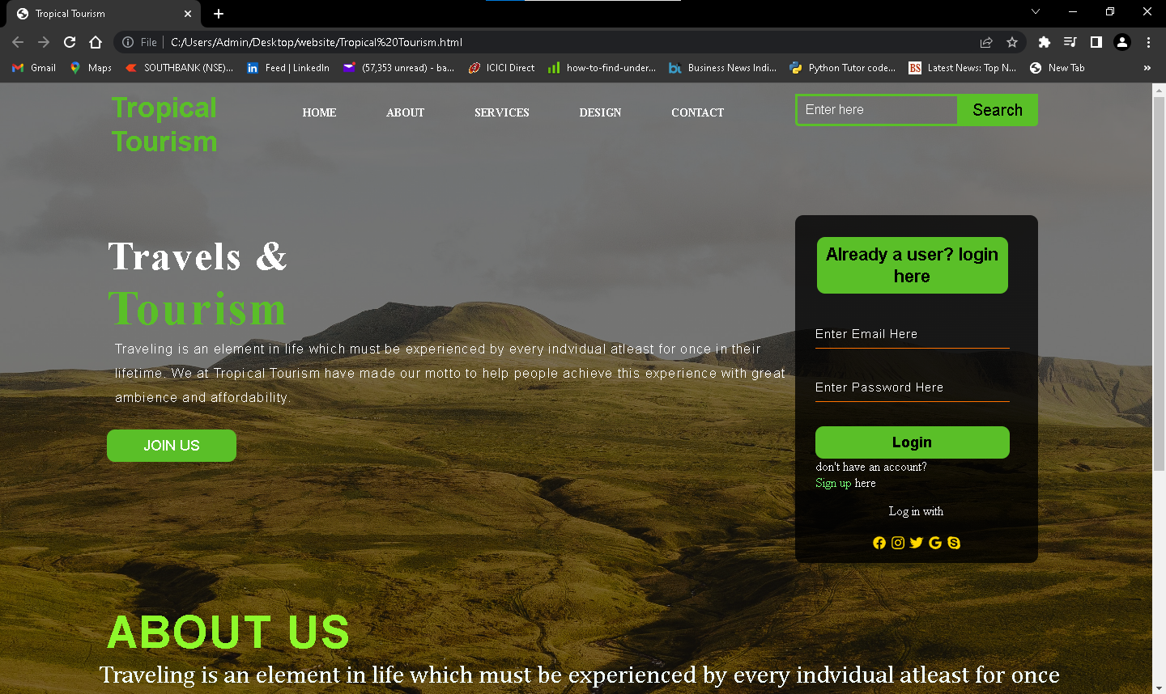

(Fig 3.1)

Here, we notice the CSS stylings used in the webpage (FIG 3.1). All the stylings are modified and suited to the theme of the webpages.

1. In this figure, we can see the demonstration of the login form validation using JavaScript.

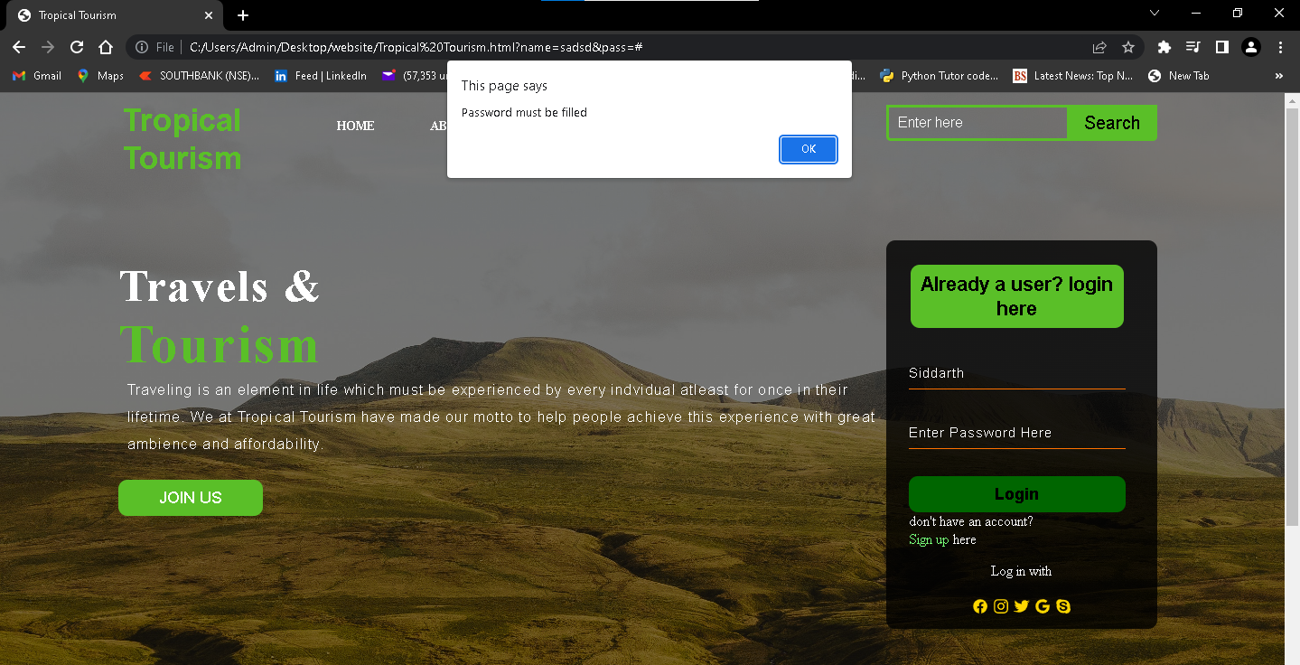

(FIG 3.2)

1. Here, we can observe the validation of the form page. The alert message pops as the password is not confirmed.

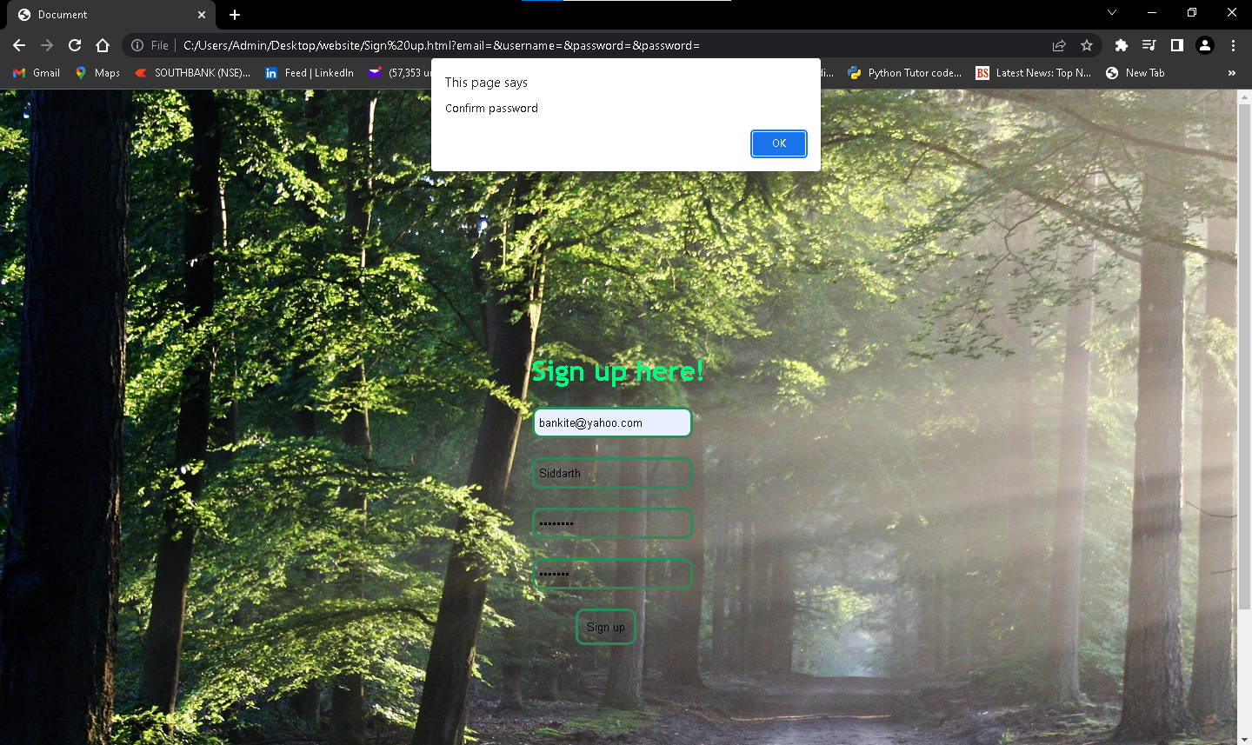

(FIG 3.3)

1. In this image below, we can see the child class selector in the service webpage.

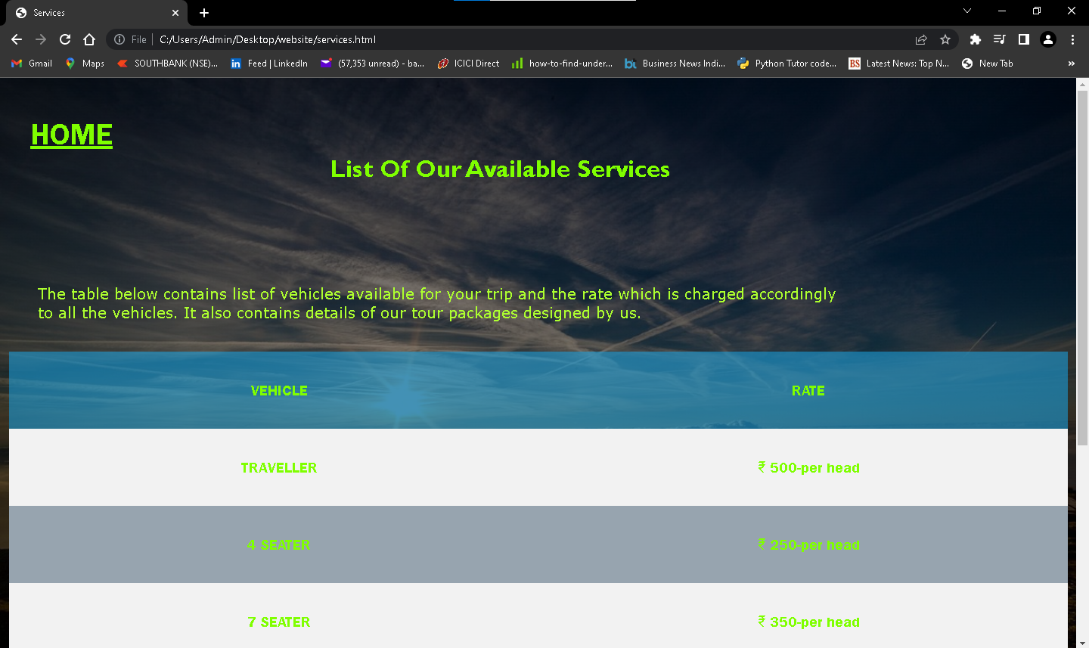

(FIG 3.4)

1. Here, we can see the usage of Flex attribute and flex box in CSS.

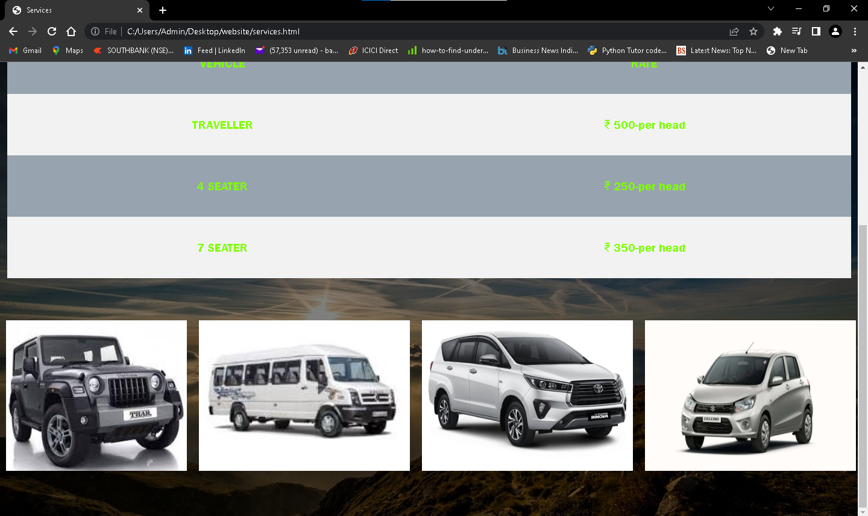

(FIG 3.5)

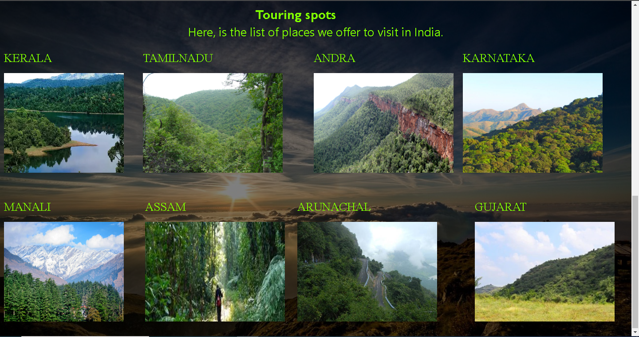

(FIG 3.6)